Meno žiaka:
Trieda:

Slovenský jazyk od 15. 2. do 19. 2. 2021

Vypracovala: Mgr. Silvia Dikejová
Prečítaj nahlas a zakrúžkuj písmená F, f:
Filoména, chudera,
sadla vedľa šoféra.
Filoména jajká,
že mu smrdí fajka.

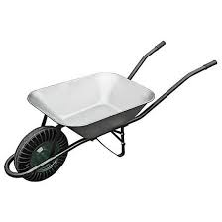
Pomenuj obrázok. Slovo napíš pod obrázok na linajku:

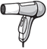
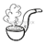
___________________________________________________________________________
....................................................................................................................................................___________________________________________________________________________

Vety prepíš písaným písmom:
Ujo Fero nafotil pekné fotky.
___________________________________________________________________________
....................................................................................................................................................___________________________________________________________________________
Františka si fúka bublifuk.
___________________________________________________________________________
.....................................................................................................................................................___________________________________________________________________________

Profesor hrá na flautu a harfu.
___________________________________________________________________________
.....................................................................................................................................................___________________________________________________________________________
Prepíš tlačené písmená na písané:
Z | ch | B | f | r | N | Š | Ž
U | G | h | Ď | t | g | Ň | k
C | r | ch | N | Ž | v | f | Ť
D | b | k | p | E | z | i | h

Čítaj:

Gabika a Gitka sa hrali s gumenou loptou. Starý otec fúkal do fujary. Fedor a mama sedeli v kuchyni. Na stole boli orechy. V chladničke boli dva jogurty.

Precvič si písanie písmen.
___________________________________________________________________________
.....................................................................................................................................................___________________________________________________________________________
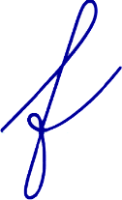
___________________________________________________________________________
.....................................................................................................................................................___________________________________________________________________________

Prečítaj a potom prepíš slová na písané:

mucha |  | orgován
kufor |  | chlieb
Ferdo |  | fúkať
regál |  | tiger
gunár |  | guma
gága |  | orech

Zakrúžkuj písmená G, g: Gágal gunár na dvore,
až mu vyschlo v gágore.
Húska krajšie gága,
v potoku sa mága.

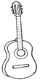
Pomenuj obrázok. Slovo napíš pod obrázok na linajku.
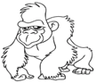

___________________________________________________________________________
.....................................................................................................................................................___________________________________________________________________________

Vety prepíš písaným písmom:

Ujo Gregor gituje obloky.
___________________________________________________________________________
.....................................................................................................................................................___________________________________________________________________________
Gitka hrá na gitare.
___________________________________________________________________________
.....................................................................................................................................................___________________________________________________________________________
Gusto strelil pekný gól.
___________________________________________________________________________
.....................................................................................................................................................___________________________________________________________________________

Precvič si písanie:
___________________________________________________________________________
.....................................................................................................................................................___________________________________________________________________________
___________________________________________________________________________
.....................................................................................................................................................___________________________________________________________________________

Prečítaj slová a prepíš na písané:

gorila |  | Gabika
chrúst |  | Gizka
guma |  | fúra
fúrik |  | kefa
trieda |  | fúkať
tiger |  | fujara
kuchyňa |  | gól

