Present simple and present continuous

1. True or False.
Read and circle True or False.
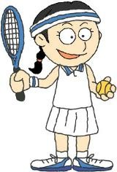 |  | I like sport. I play tennis every weekend and I watch tennis matches on TV every time there is one! I also play basketball on Fridays. I am not very good so I am learning with a trainer. Right now I am looking for information about famous players on the internet. My sister doesn’t like sport. Every weekend she stays at home and watches TV! At the moment she is helping our dad cook dinner in the kitchen.
a. | I play tennis every Saturday and Sunday. |  | True | False
b. | I’m playing tennis now. |  | True | False
c. | I play basketball every day. |  | True | False
d. | I’m using the computer now. |  | True | False
e. | My sister is watching TV now. |  | True | False

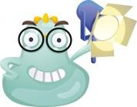 | We use the present simple to talk about routines – what you do every day or every week. We use the present continuous to talk about things you are doing now.  I watch cartoons every day. I’m watching a film now.

2. Where does it go?
Do we usually use these words with the present simple or present continuous? Write them in the correct group.

every day | now | on Mondays | right now | always
usually | sometimes | at the moment | never | every weekend

present simple | present continuous
every day

3. Fill it in!
Write the verbs in (brackets) in the present simple or present continuous.
a. | I sleep for a long time at weekends. (sleep)
b. | At the moment our two cats . (sleep)
c. | I computer games every day! (play)
d. | I outside with my friends now because it’s raining. (not play)
e. | Right now my mum a magazine. (read | )
f. | My dad usually a bedtime story to me and my brother. (read)
g. | Now we our favourite cartoon. (watch | )
h. | On Sundays we TV in the evening. (not watch)

4. Write and draw!
Write about what you do every day. Then write about what you are doing now. Draw a picture!
Every day I ........................................................

...........................................................................

...........................................................................

Right now I ........................................................

...........................................................................

...........................................................................

